Forex trading is the simultaneous buying of one currency and selling of another.

EUR/CHFEurozone / Switzerland“euro swissy”EUR/GBPEurozone / United Kingdom“euro pound”EUR/CADEurozone / Canada“euro loonie”EUR/AUDEurozone / Australia“euro aussie”EUR/NZDEurozone / New Zealand“euro kiwi”EUR/SEKEurozone / Sweden“euro stockie”EUR/NOK

EUR/JPYEurozone / Japan“euro yen” or “yuppy”GBP/JPYUnited Kingdom / Japan“pound yen” or “guppy”CHF/JPYSwitzerland / Japan“swissy yen”CAD/JPYCanada / Japan“loonie yen”AUD/JPYAustralia / Japan“aussie yen”NZD/JPY

GBP/CHFUnited Kingdom / Switzerland“pound swissy”GBP/AUDUnited Kingdom / Australia“pound aussie”GBP/CADUnited Kingdom / Canada“pound loonie”GBP/NZD

An exotic currency is a currency from countries with developing or emerging markets.

Keep in mind that these pairs aren’t as heavily traded as the “majors” or “crosses,

Due to the overall lower degree of liquidity, exotic currency pairs tend to be far more sensitive to economic and geopolitical events.

political scandal or unexpected election results can cause an exotic pair’s exchange rate to swing violently.

exotics, here’s a more comprehensive list.

AEDUAE DirhamARSArgentinean PesoAFNAfghanistan AfghaniGELGeorgian LariMYRMalaysian RinggitAMDArmenian DramGYDGuyanese DollarMZNMozambique new MeticalAWGAruban FlorinIDRIndonesian RupiahOMROmani RialAZNAzerbaijan New ManatIQDIraqi DinarQARQatari RialBHDBahraini DinarIRRIranian RialSLLSierra Leone LeoneBWPBotswana PulaJODJordanian DinarTJSTajikistani SomoniBYRBelarusian RubleKGSKyrgyzstani SomTMTTurkmenistan new ManatCDFCongolese FrancLBPLebanese PoundTZSTanzanian SchillingDZDAlgerian DinarLRDLiberian DollarUZSUzbekistan SomEGPEgyptian PoundMADMoroccan DirhamWSTSamoan TalaEEKEstonian KroonMNTMongolian TugrikMWKMalawi KwachaETBEthiopian BirrTHBThai BahtTRYNew Turkish LiraZARSouth African RandZWDZimbabwe DollarBRLBrazilian RealCLPChilean PesoCNYChinese Yuan RenminbiCZKCzech KorunaHKDHong Kong DollarHUFHungarian ForintILSIsraeli ShekelINRIndian RupeeISKIcelandic KronaKRWSouth Korean WonKWDKuwaiti DinarMXNMexican PesoPHPPhilippine PesoPKRPakistani RupeePLNPolish ZlotyRUBRussian RubleSARSaudi Arabian RiyalSGDSingaporean DollarTWDTaiwanese Dollar

G10 currencies

Traders regularly buy and sell them in an open market with minimal impact on their own international exchange rates.

United StatesdollarUSDEuropean UnioneuroEURUnited KingdompoundGBPJapanyenJPYAustraliadollarAUDNew ZealanddollarNZDCanadadollarCADSwitzerlandfrancCHFNorwaykroneNOKSwedenkronaSEKDenmarkkroneDKK

the forex market has neither a physical location nor a central exchange .

Forex market is considered an over-the-counter (OTC) market

fact that the entire market is run electronically

The U.S. dollar is the medium of exchange for many cross-border transactions . For example, oil is priced in U.S. dollars. Also called “ petrodollars .” So if Japan wants to buy oil from Saudi Arabia, it can only be bought with the U.S. dollar. If Japan doesn’t have any dollars, **it has to sell its yen first and buy U.S. dollars**. You wanted to buy 1000 euros you would need to pay for 1110 dollars in order to get it, **this act of paying the quote currency is called selling and this act of buying the base currency is buying**

most of the trading volume comes from traders that buy and sell based on the short-term price movements of currency pairs .

market liquidity, which is the ability to buy or sell a large quantity of something with minimal price impact, very HIGH.

A liquid market environment like forex enables huge trading volumes to happen with very little effect on the price , or price action

Financial instruments

currency exchange-traded funds (or ETFs), forex CFDs , and forex spread betting.

**Futures** are contracts to buy or sell a certain asset at a specified price on a future date (That’s why they’re called futures!).

An “option” is a financial instrument that gives the buyer the right or the option, but not the obligation, to buy or sell an asset at a specified price on the option’s expiration date

If a trader “sold” an option, then he or she would be obliged to buy or sell an asset at a specific price at the expiration date.

A **currency ETF** offers exposure to a single currency or basket of currencies. Currency ETFs allow ordinary individuals to gain exposure to the forex market through a managed fund without the burdens of placing individual trades.

ETFs are created and managed by financial institutions that buy and hold currencies in a fund

offer shares of the fund to the public on an exchange allowing you to buy and trade these shares just like stocks

**spot FX** market is an “ off-exchange ” market, also known as an over-the-counter (“OTC”) market.

off-exchange forex market

iquid financial market that operates 24 hours a day.

no central trading location or “exchange”.

Unlike currency futures, ETFs, and (most) currency options, which are traded through centralized markets, spot FX are over-the-counter contracts (private agreements between two parties).

primary market for FX is the “ interdealer ” market where FX dealers trade with each other. A dealer is a financial intermediary that stands ready to buy or sell currencies at any time with its clients.

The interdealer market is only accessible to institutions that trade in large quantities and have a very high net worth. This includes banks, insurance companies, pension funds, large corporations, and other large financial institutions manage the risks associated with fluctuations in currency rates.

In the spot FX market, an institutional trader is buying and selling an agreement or contract to make or take delivery of a currency .

FX transaction is a bilateral (“between two parties”) agreement to physically exchange one currency against another currency.

This is known as T+2 (“Today plus 2 business days”).

**Retail Forex (this is for poor traders without much margin/capital/money to invest)** There is a secondary OTC market that provides a way for retail (“poorer”) traders to participate in the forex market.

granted by so-called “ forex trading providers “.

Forex trading providers are also known as “ forex brokers “. Technically, they are not brokers because a broker is supposed to simply act as a middleman between a buyer and a seller (“between two parties”). But this is not the case, because a forex trading provider acts as your counterparty. This means if you are the buyer, it acts as the seller. And if you are the seller, it acts as the buyer. To keep things simple for now, we will still use the term “forex broker” since that’s what most people are familiar with but it’s important to know the difference.

you are actually trading a contract to deliver the underlying currency, rather than the currency itself.

not just a contract, it’s a leveraged contract. Ito yung **hiram mo na pera from your forex broker**

Retail forex brokers let you trade with leverage which is why you can open positions valued at 50 times the amount of the initial required margin .

So with $2,000, you can open a EUR/USD trade valued at $100,000.

if you bought British pounds with U.S. dollars, you would close out the trade by selling British pounds for U.S. dollars. This is also called offsetting or liquidating a transaction.

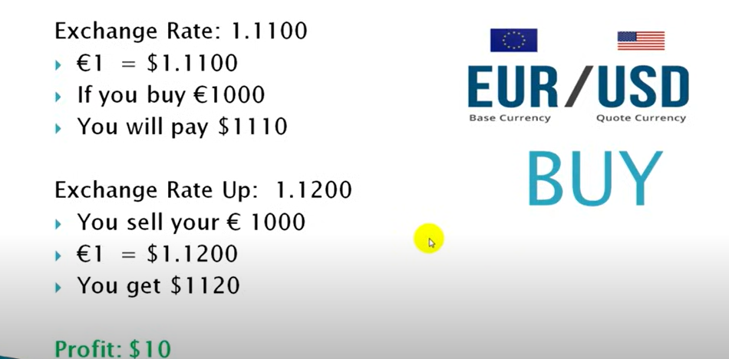

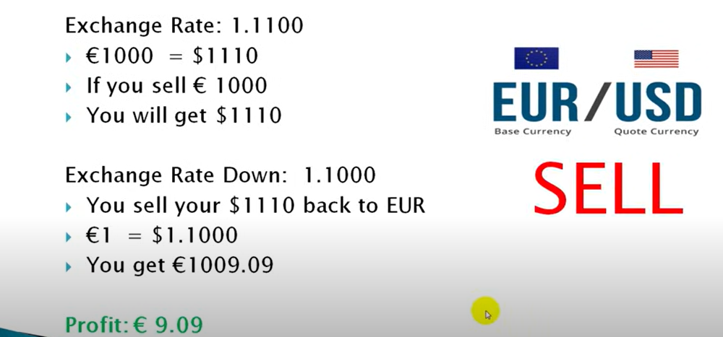

eur/usd

Day 1 1 to 1.1110 - I buy 1000 eur by paying/selling 1110 usd

Day 2 1 to 1.2020 - I buy 1000 eur by paying/selling 1202 usd

Day 3 1 to 1.3 - I buy 1000 eur by paying/selling 1300 usd

So far I bought €3000 euros for $3612 us dollars

If I sell 3000 euros back to us dollar

Since €1 to $1.3 is the x rate

€3000 euros * 1.3 = $3900

If we were to decide to sell our €3000 euros back to us dollars this day before any kind of market drop it would be $3900 (since €1 to $1.3) which would be higher than all our total cost to pay for the €3000 euros we bought, hence making our profit $3900 - $3612 = $288

Day 4 the market does indeed drop slightly (€1 to $1.295)

Given we have now still our $3900 us dollars we can sell our $3900 back to euro and because the x rate is currently €1 to $1.295 the equation would be

x : $3900 = €1 : $1.295

€1.295x = $3900

x = $3011

Before the drop in market $3900 us dollars was €3000 euros but the drop in market allowed us to sell our $3900 us dollars back to not €3000 euros but now €3011 euros

Which makes our profit €3011 - €3000 or €11 euros